TIPS
Technical Innovation And Professional Services

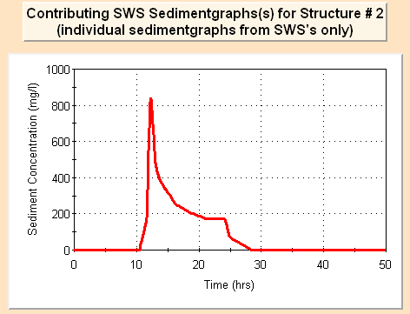SEDCAD®
SEDCAD® is a comprehensive software package that enables hydrologists to evaluate andanalyze the volume and rate of runoff from a watershed and to design the size and location of mine sedimentation ponds and diversions so that these structures will be effective in handling the runoff volumes and in containing sediment from mine disturbance that otherwise may flow offsite into streams and lakes. The program enjoys extensive use design of various hydraulic structures such as determining culvert sizing, sufficient channel armoring, design of silt fencing, etc., allowing the user to easily adjust multiple design options for the proposed structure to achieve an optimal fit to the characteristics of the contributing watershed. SEDCAD has been a key core software component in the OSM’s TIPS program since 1988.

SELECTED FEATURES:
- Design and evaluate drainage and sediment control structures for mine permitting, reclamation and abandoned mine lands.
- SEDCAD is capable of predicting the performance of sediment basins, sediment traps, silt fences, check dams, plunge pools and grass filters.
- Culvert design routine sizes pipes based on headwater, tailwater, and pipe characteristics.
- Allows user to choose from a list of often-used design storms, entering an actual rainfall event or customizing.
- Use Muskingum method for routing.
- No restrictions in networking structures with regard to spatial placement.
- The curve-number method has been expanded to enable more accurate designs for disturbed, reclaimed and forested areas.
- Hydrographs and sedimentgraphs are developed for each sub-watershed.
- Apply RUSLE to calculate sediment load.
SEDCAD for Mine Permitting & Reclamation

Obtaining Software
This software is available under OSM’s license management system – KeyServer

SMCRA Benefits and Uses
- Designing and evaluating erosion prevention and drainage control structures for permitting, reclamation and abandoned mine lands.
- Predicting the effectiveness of sediment control structures.
- Predicting peak flow, runoff volume and sediment load to determine probable hydrologic consequences.

TIPS Training Classes
Training classes are offered on a yearly schedule

Need Help????
Contact SEDCAD Software Manager Omar Beckford, obeckford@osmre.gov
Kristin Brown, kbrown2@osmre.gov

