GWB17/2023 Setup Instructions
In fall 2020, OSM purchased four “floating” licenses of Geochemist Workbench. The floating licenses require a network connection to check out a license. The latest version of GWB (v.17/2023) has a “borrow” feature that allows users to borrow a floating license to that doesn’t require connection to the internet for GWB to function.

- If a previous version of GWB is installed, login as Admin and click the Support Tab and then click Check for Updates.
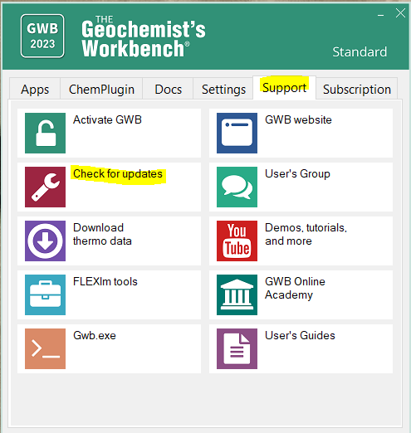
- If it is a new installation, to download the GWB 17/2023, hold the Control key and left mouse click on the following link: http://www.gwb.com/download.php?order=200802-3451&v=a&ver=gwb&k=fed4fe06506e940abf6ac568ddab6e4c
- Open Workbench -
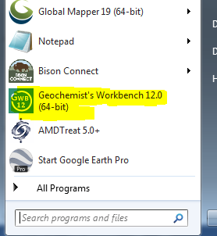
- In the GWB panel, select the Support Tab and then select “Activate GWB”
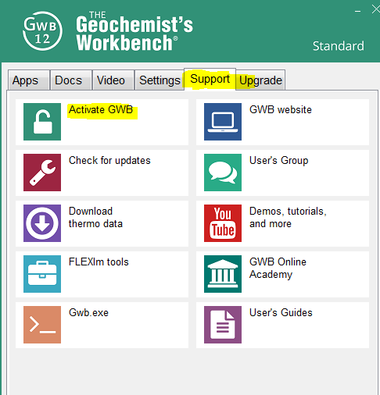
- In the GWB Activation Utility, Click “New” and then contact Dawn Pacula (dpacula@osmre.gov) to obtain the activation code. Enter the activation code then select “Activate.”
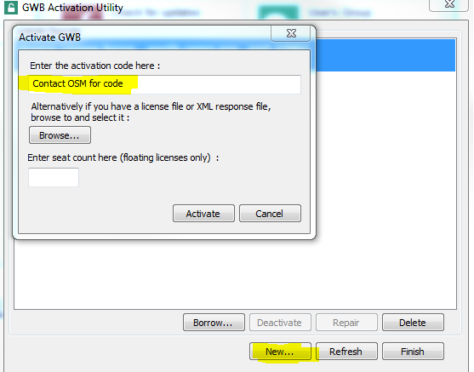

- Now the GWB Activation Utility should show that the License is active. Close the GWB Activation Utility.
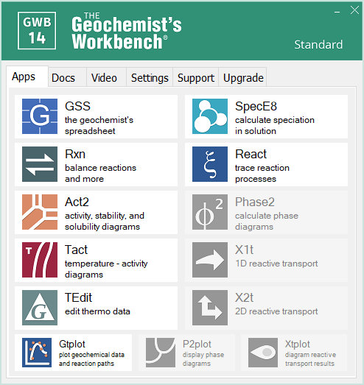
- The GWB modules should be activated under the Apps tab

.

