Installing Groundwater Vistas version 8

General Instructions

Installation Instructions

General Instructions

- Software administrator privilege is needed to install the software.

- Keyserver client software must be installed on the computer for the software to operate. You can check for Keyserver, by accessing Start → All Programs → Sassafras K2 → Key Verify. A dialog box will identify a server under “Name” and Status as “Valid”. If there is no Sassafras K2 folder under All Programs, download either the current 32 or 64 bit version of K2Client appropriate to your computer from https://www.tips.osmre.gov/software/downloads.shtm. Follow the installation instructions posted on the webpage.

- Backup any files from existing Groundwater Vistas models.

- Uninstall any previous version of Groundwater Vistas before installing this version.

Installation Instructions
- Open Sharefile link that you were sent to download the GWV8 package as a zip file.

- Extract the zip file to your desktop.

- Open the “GroundwaterVistas 8-64bit” folder.

- Run “Setupx64.msi” as Administrator.

- Installer Window pops up, click “Next.”

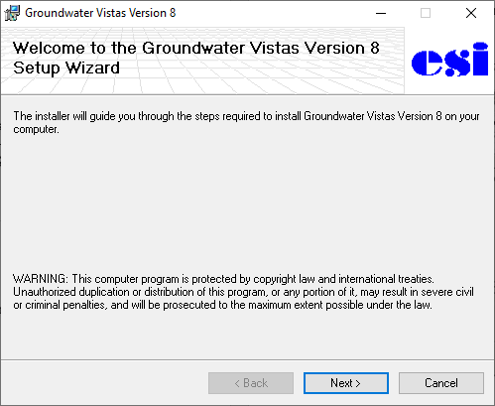
- Review the License Agreement, and click “I agree” then “Next” if you accept and continue installation.
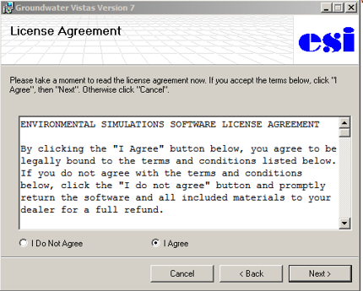
- Click “Next” again
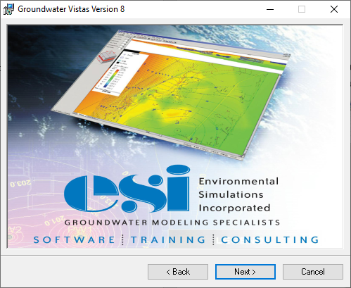
- Select “Install Documentation” and “Install Tutorial Documents,” then click “Next.”
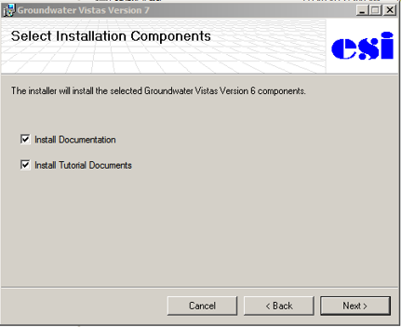
- Install in folder C:\GWV8\ or preferred location. Select “Everyone” to allow any person using the computer to use Groundwater Vistas Version 7. Then click “Next.”
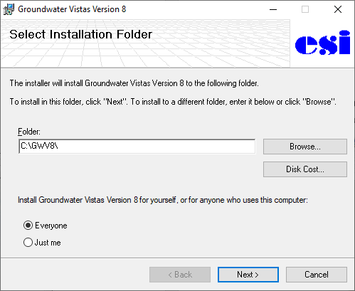

- Click “Next” to confirm installation.
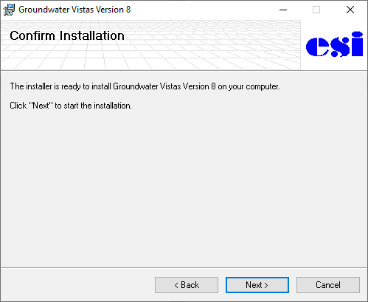
- The program will install, and may take a few minutes.
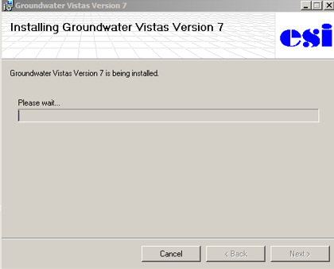
- The User Account Control box will pop up ask if the publisher is allowed to make changes to the computer. Select “Yes.”
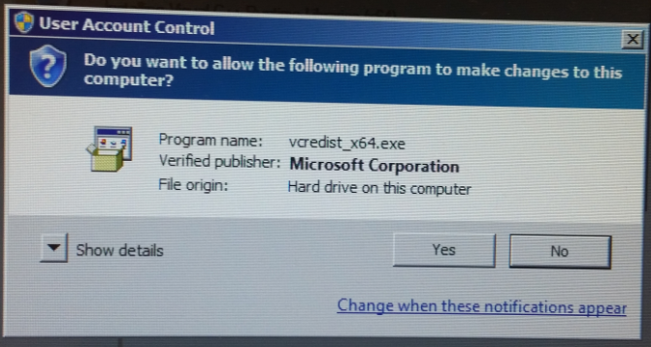
- When the Installation Complete box appears, click “Close” to exit the installation.

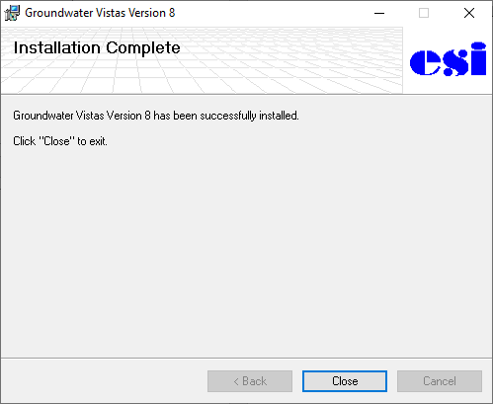
- The GWV8 program should be ready to run. Upon opening the software, a box appears and provides information about KeyServer. Click OK to utilize one of the shared licenses.

- If the KeyServer box does not appear, close the program and call Sarah Kreitzer immediately at 412-937-2874.

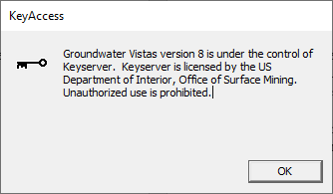

- For questions or comments, please contact Sarah Kreitzer at 412-937-2874 or skreitzer@osmre. gov.

